Phillip Pi’s Samsung Galaxy S6 Edge’s Android and Apple iPhone 6’s iOS Spark App’s User Experience (UX) Issues (2016’s 3/16-4/11; all times are based on pacific daylight time (PDT)). Some of these are also considered (enhancement/idea/suggestion)s [not added into GitHub].

Setup Details Used: 64-bit W7 EE SP1 on a Lenovo Thinkpad W530 (default 125% medium DPI), Mac OS X v10.10.5 (Yosemite) on a 15” MacBook Pro (Retina; early 2013), iOS v9.(2.1 & 3.(1 as of 4/31/2016)) on a SIMless iPhone 6, and Android (v5.1.1 & 6.0.1 [versions changed on the 23rd‘s morning]) on a SIMless Samsung Galaxy S6 edge. All softwares were usually updated to the (lat/new)est versions when possible. Version and build numbers were noted in each issue below. Also, used production web.ciscospark.com.

Issue: Need to add user presences into Android and iOS apps. Currently only computers’ v1.0… clients have them. E-mailed wx2support@external.cisco.comwith my “Feedback web-client_a5a8e41d-3309-476d-a5ef-4bf6d04c3370” and added to GitHub (https://sqbu-github.cisco.com/WebExSquared/wx2-ios-client/issues/3511 and https://sqbu-github.cisco.com/WebExSquared/wx2-android/issues/3028).

Issue: “START USING SPARK”’s intro(duction) screens and its sign in screen, does not seems to always change its screen orientations in iOS app v1.31 (14927) on 3/29/2016. They stay stuck in that orientation. Documented into https://sqbu-github.cisco.com/WebExSquared/wx2-ios-client/issues/3512.

Issue: Android app (reproduced in v1.10.2605 in Android v6.0.1; did not see this in iOS app) should open new web browser tab instead of reusing the current tab like in the web clients:
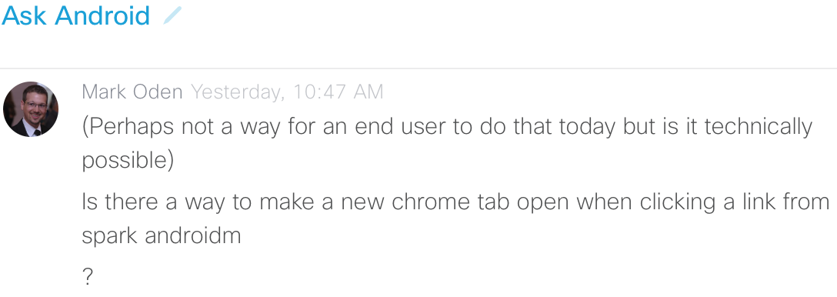
Documented into GitHub: https://sqbu-github.cisco.com/WebExSquared/wx2-android/issues/3029.

Two Issues -- Android app (v1.10.2605 in Android v6.0.1; did not see this in iOS app)’s Help’s Report a Problem’s Contact Support:
- It gets stuck forever as shown in the below three screen (capture/shot)s from 3/24/2016 (also seen on the 25th; rebooting Samsung Galaxy S6 edge didn’t fix it). Added to https://sqbu-github.cisco.com/WebExSquared/wx2-android/issues/3030.
- “Contact Support” screen looks empty with lots of white (space/area)s. Maybe that link should be on the previous page to skip this screen and save user’s time? Reported to https://sqbu-github.cisco.com/WebExSquared/wx2-android/issues/3031 and support@ciscospark.com’s Feedback Report #34436.

Issue: Clicking on the readers’ circular avatar images do not anything like shown in the below (screen shot/capture)s from Spark’s iOS app v1.31 (14927) on 3/25/2016’s evening. Android’s app and other clients show details from these actions from users’ avatar images and +numbers bubble to view the rest of the readers. According to Ben Shanfelder’s and Riley Marsh’s answers in “Ask iOS” room during the evening, they never had actions because they were never implemented.
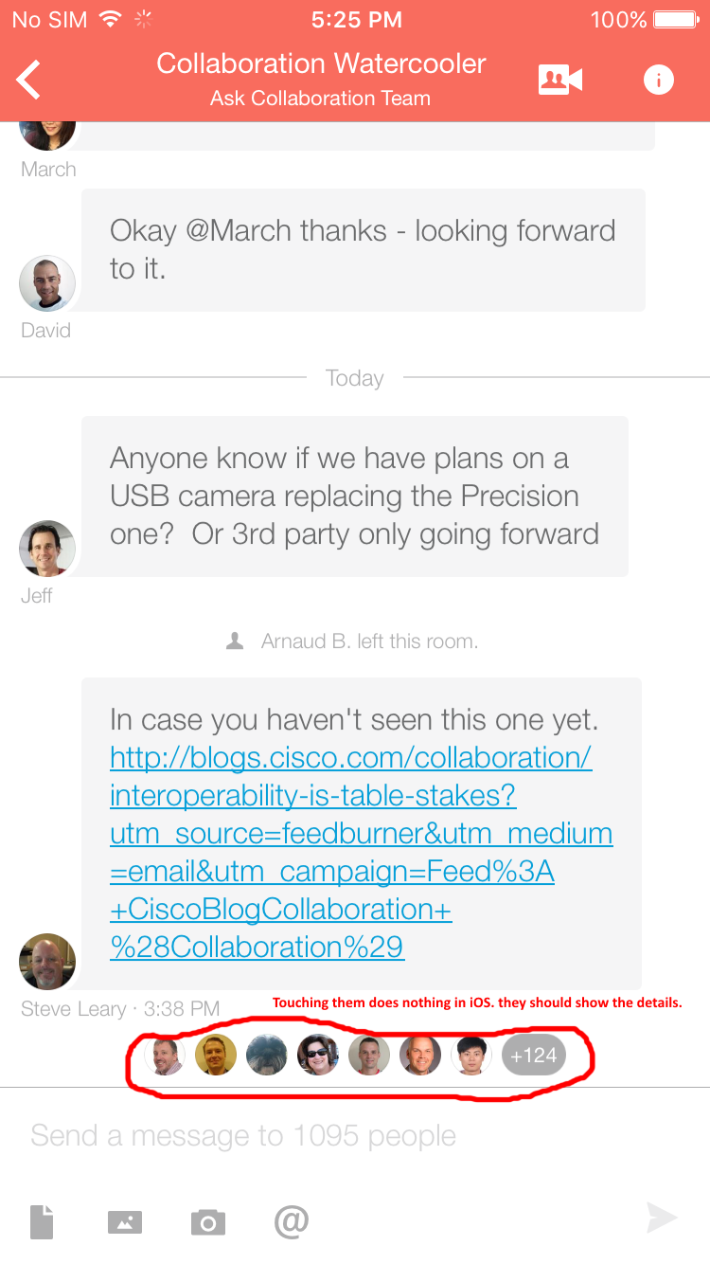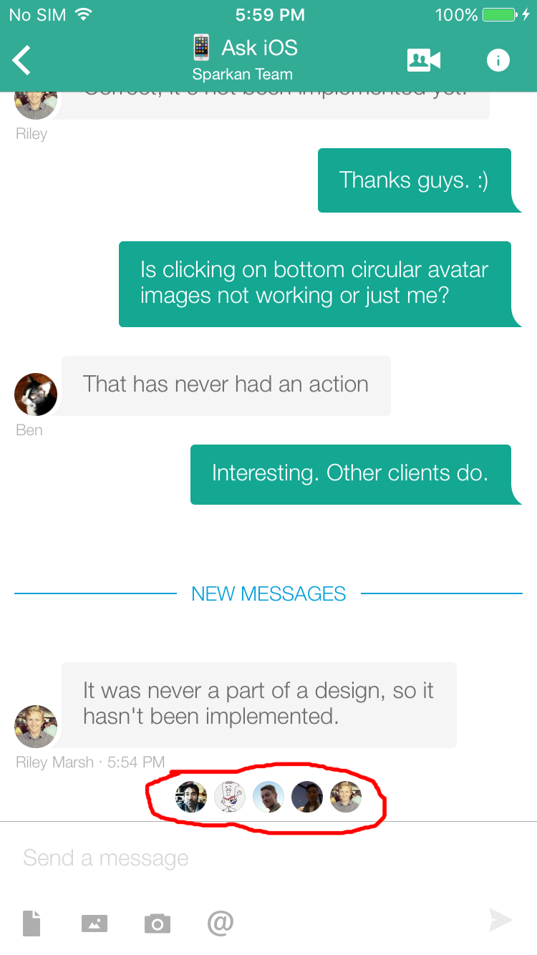
Reported to both https://sqbu-github.cisco.com/WebExSquared/wx2-ios-client/issues/3521 and support@ciscospark.com as a Cisco Spark Feedback Report #33626 about this issue.
Issue – Android app client v1.10.2605 (Android v6.0.1)’s coach mark’s Tour with its room’s “Video calls” has an overlapping horizontal thick status progress bar as shown in the left portrait orientation screen shot/capture on 3/25/2016 (still exists in v1.10.2642 on 4/11/2016 at about 9:25 AM). Did not see this problem when the the display orientation was in widescreen landscape though. Reported to https://sqbu-github.cisco.com/WebExSquared/wx2-android/issues/3037 and support@ciscospark.com’s Feedback Report #34437.
Two Issues in “Start using Spark”’s intro(duction)s from both Android app client v1.10.2605 (Android v6.0.1; 3/25/2016) and iOS app v1.31 (14927) [iOS v9.3.x]:

1. Smartphone images, before the sign in screen in both iOS and Android apps, are cropped. There is no way to view all like lack of scrolls. In portrait orientations in the below screen capture/shot (left is from Samsung Galaxy S6 edge and right is from iPhone 6):
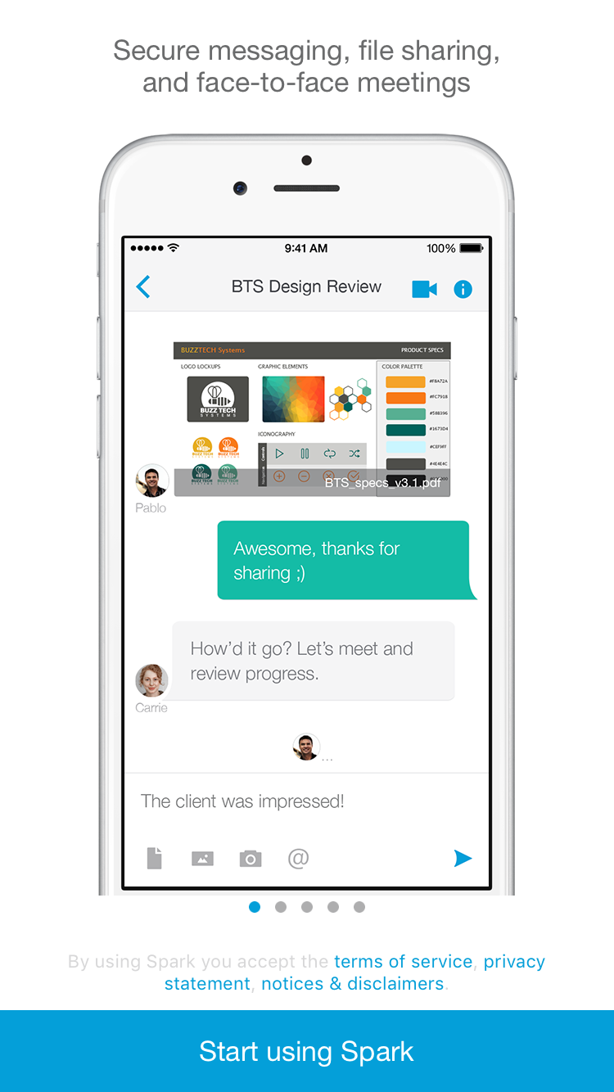
Android’s app landscape screen shows:
Documented into GitHub:
iOS: https://sqbu-github.cisco.com/WebExSquared/wx2-ios-client/issues/3524
Android: https://sqbu-github.cisco.com/WebExSquared/wx2-android/issues/3038

2. Android app also shows “Start using Spark” in all caps unlike iOS app’s. They are inconsistence with each other. Documented into https://sqbu-github.cisco.com/WebExSquared/wx2-android/issues/3039.

Both issues also e-mailed to support@ciscospark.com’s Feedback Report #34439.

Issue – Spark’s iOS client app v1.31 (14927)’s login screens look messy when using widescreen landscape screen orientation instead of portrait. Below are a couple screen (capture/shot)s in iOS v9.3.1 on 3/29/2016 early afternoon.
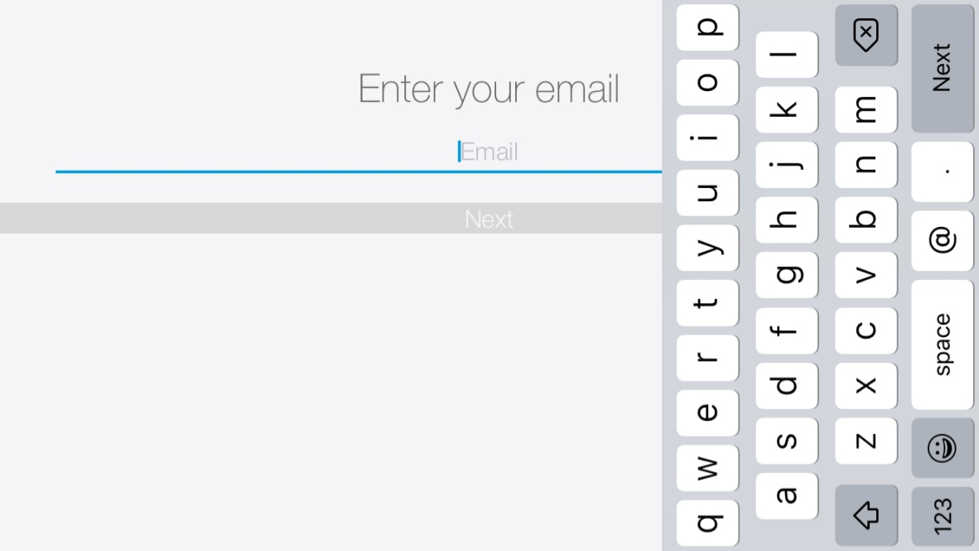
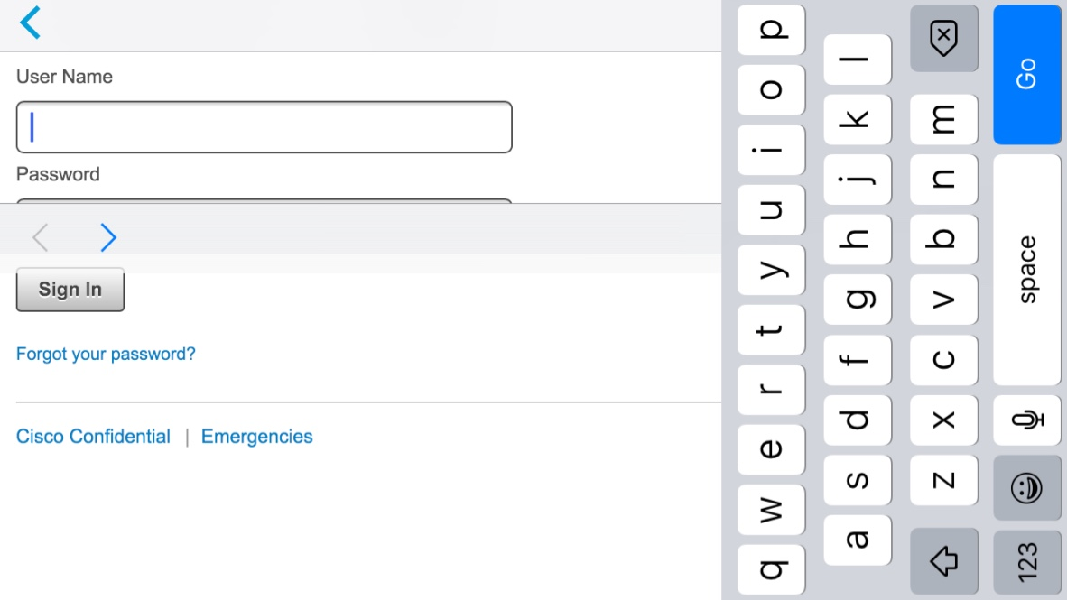
Android’s app did not have this problem. Documented into https://sqbu-github.cisco.com/WebExSquared/wx2-ios-client/issues/3528 and support@ciscospark.com’s Feedback Report #34442.
Issue – There is no way to go back or exit Spark’s Android app normally (beside doing it externally with Android’s on screen force stop and close options, and using the physical back button [gets stuck in a loop unless I do it fast in pressing many times]) after idling too long (30+ minutes) in CEC’s 2nd login screen (username + password) after entering my valid e-mail address. A couple screen (shot/capture)s as shown below from v1.10.2605 in Android v6.0.1 on 3/30/2016 (also see on 4/5/2016 2:52 PM PDT with v1.10.2617)):
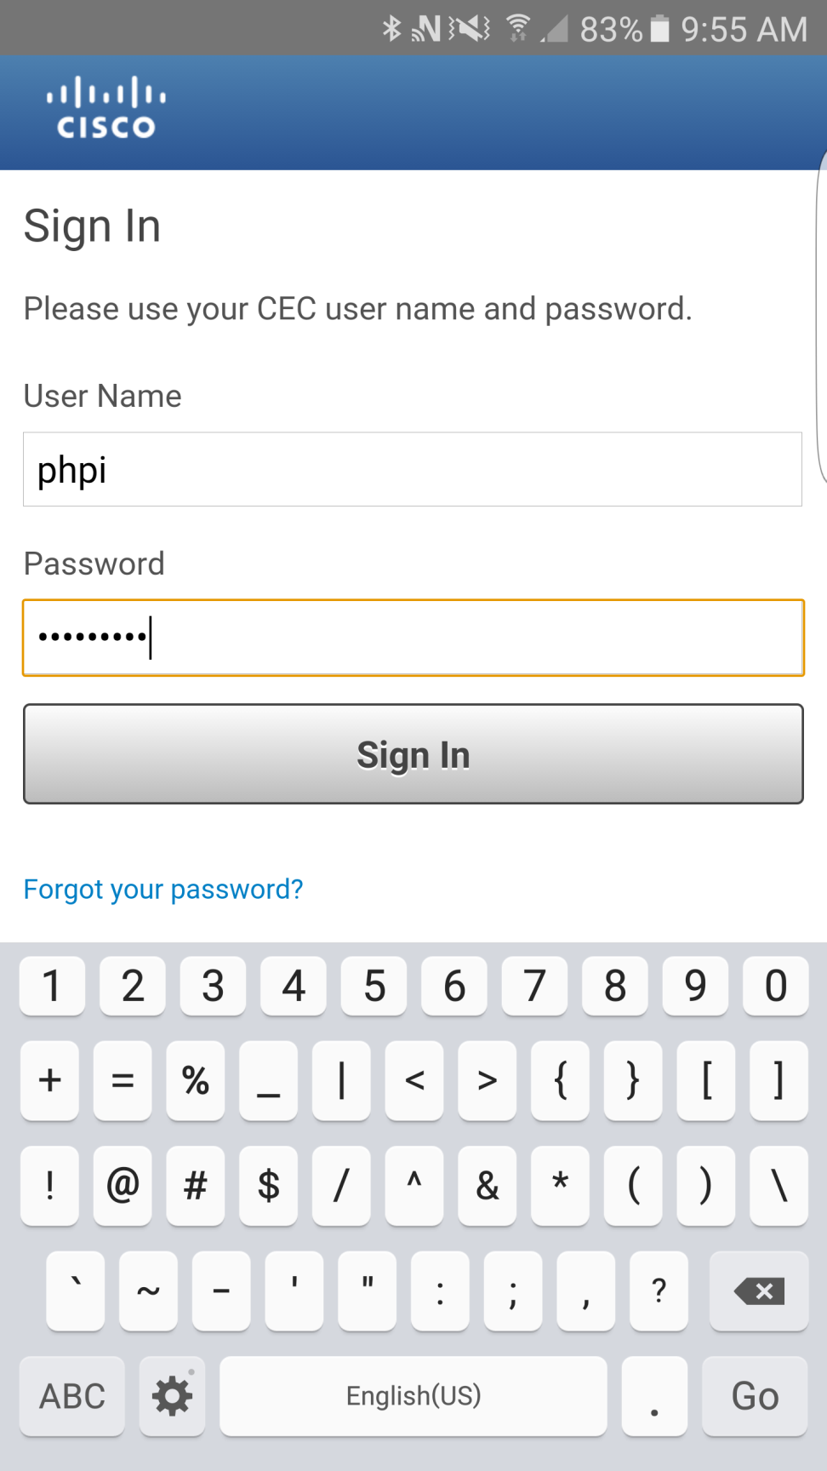
Documented into https://sqbu-github.cisco.com/WebExSquared/wx2-android/issues/3048 and support@ciscospark.com’s Feedback Report #34444.
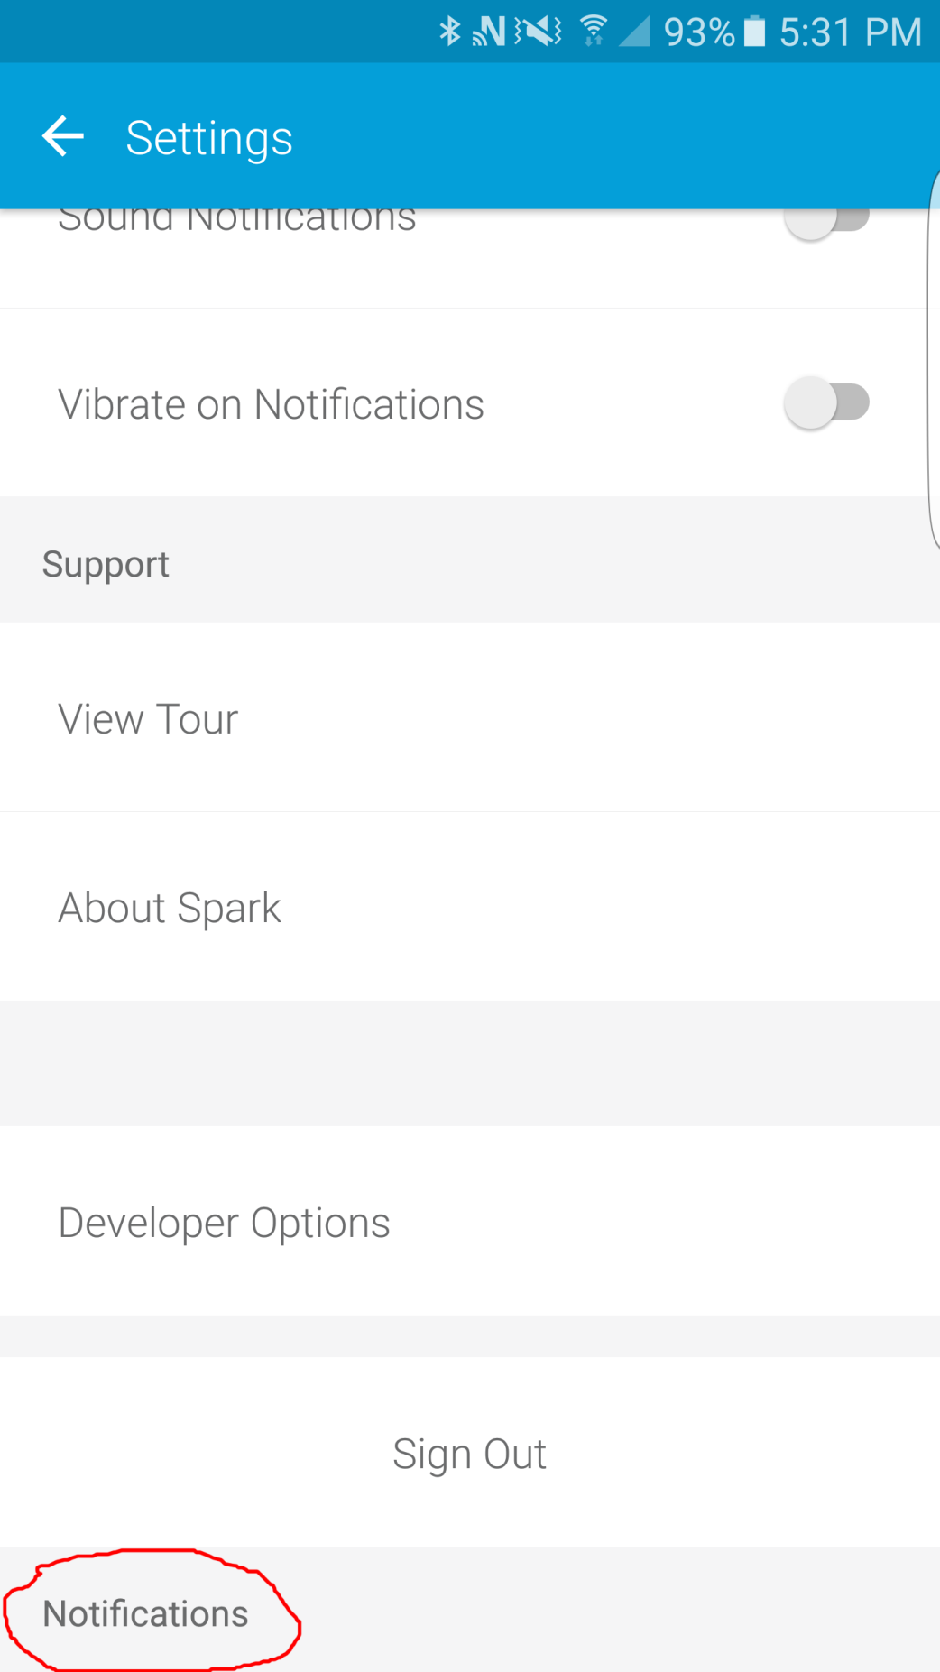
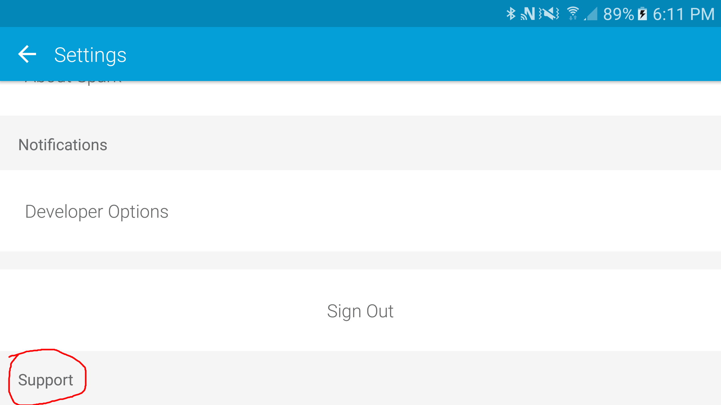
Logged in Spark’s Android app v1.10.2605’s settings show these two repeated odd/weird text locations below “Sign Out” option on 3/30/2016. Their texts depend on which screen’s orientation. In protrait orientation, “Notifications” text is shown. In landscape orientation, “Support” text is shown. Clicking on them did nothing, but they appear to be from above titles in the same screen (scroll up in the app). Reported to https://sqbu-github.cisco.com/WebExSquared/wx2-android/issues/3044 and support@ciscospark.com’s Feedback Report #34445.

iOS app v1.31 (14927) did not show this problem.

Two Issues on 4/4/2016:
1. Two broken/missing images in mobile apps’ new support ticket screen in its top right corner (even when scrolled down) and at the center’s bottom):
Android app v1.10.2613 (Android v6.0.1)’s Help’s “Report a Problem”’s “CONTACT SUPPORT” blue button:
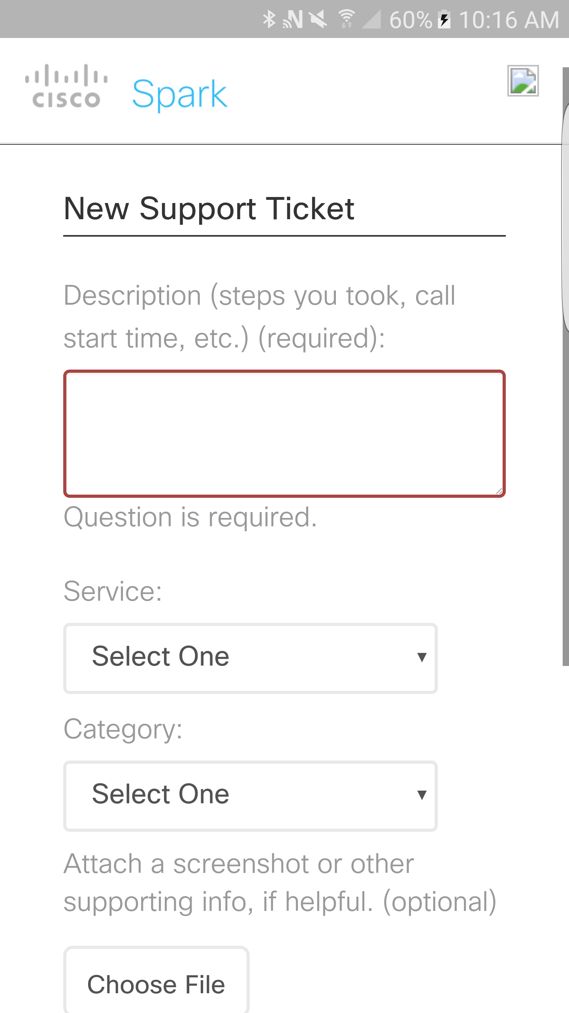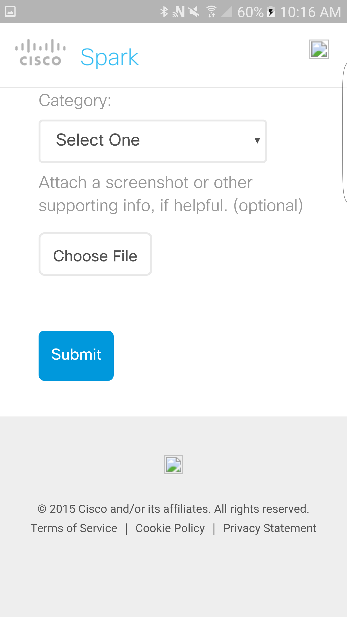
Also missing images (empty square boxes) seen with iOS app v1.31 (14927) in iOS v9.3.1 through its “Settings”’s “Support”’s “Submit Feedback to Cisco” (again in the top right corner (even after scrolling down) and center’s bottom):
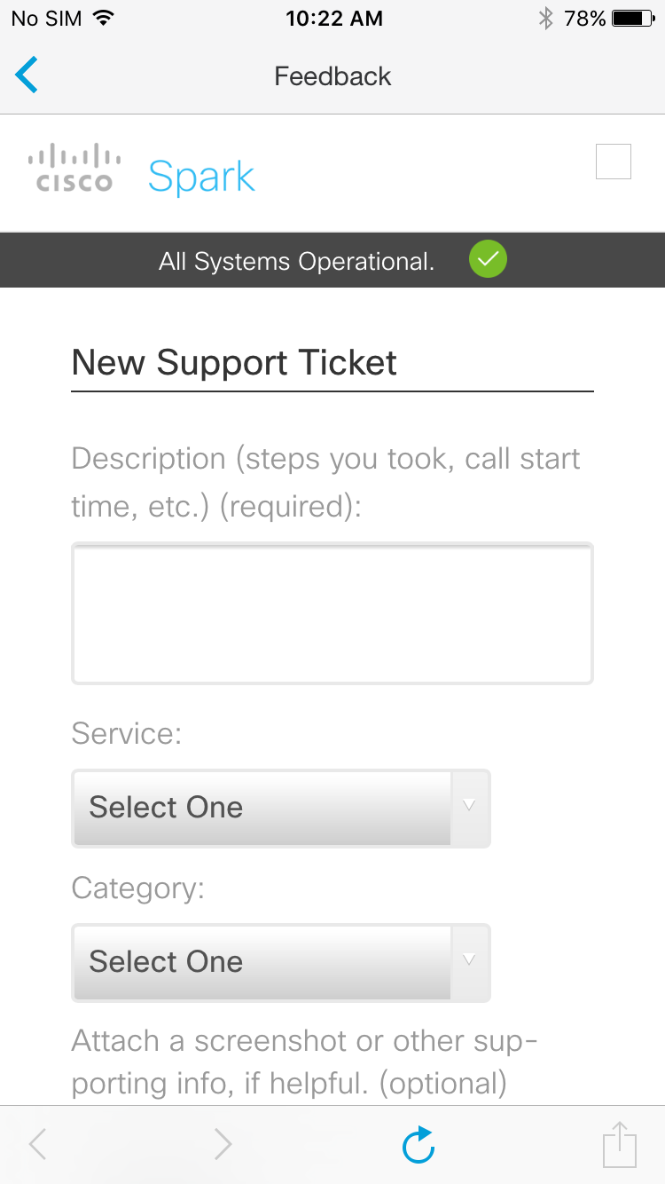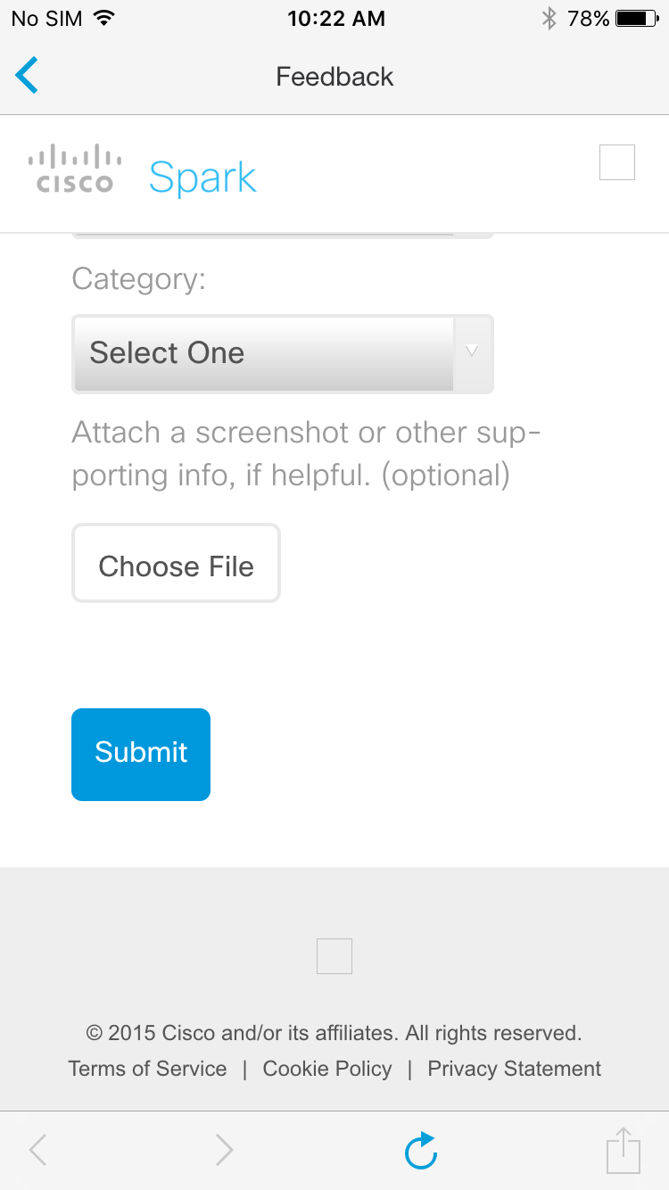
https://sparktrials.ciscospark.com/customer/portal/emails/new is the web page shown in the mobile apps. Firefox v45.0.1, Chrome v49…, and Internet Explorer v11 web browsers show missing https://www.webex.com/ciscospark/includes/images/cisco-logo.png and http://www.webex.com/ciscospark/includes/images/nav-button-bg.png. Both go to https://www.ciscospark.com/.
2. Only in Android app, there is no onscreen back/exit/cancel/abort to get out of this “New Support Ticket” Feedback screen. In iOS app, there are onscreen “<” icons on the top and bottom (with other options) left corners to go back. Android should include on screen navigation options like in iOS app.

Thanks to guys in “Android app #feedback” Spark’s room for the tips and help on these issues. Stian Stryni beat me in creating a report too: https://sqbu-github.cisco.com/WebExSquared/wx2-android/issues/3034, but I did e-mail support@ciscospark.com as Feedback Report #34448.

